ALLAN PARK MEDICAL PRACTICE
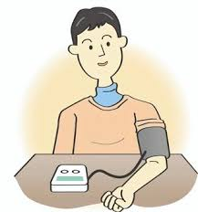
If you have one of our loan Blood Pressure machines please can you hand it back in to the practice as we are running low.
Thank you!

